

Foundations of Programming

Assignment No.: 22
PROBLEM STATEMENT: Write a menu driven program in C to perform various string operations using in-built functions.

OBJECTIVE:

- To understand the concept of strings in the C programming language.
- To learn how to use built-in string functions for string manipulation.
- To perform operations such as length calculation, copying, concatenation, comparison, and reversal using menu options.
.

THEORY:
In the C programming language, a string is a sequence of characters terminated by a null character ('\0'). Strings are stored in character arrays and manipulated using functions available in the string.h header file.
Common built-in string functions include strlen() for finding the length of a string, strcpy() for copying one string to another, strcat() for concatenating two strings, and strcmp() for comparing two strings.
A menu driven program allows the user to select different operations from a list of options. Based on the user’s choice, the corresponding string function is executed. This approach makes the program interactive and easy to use.

PLATFORM: Linux

CODE:
#include <stdio.h>
#include <string.h>
#include <ctype.h>
int main()
{
int len,n=0,x;
char str1[20],str2[20],rev[20];
printf("Enter a string : ");
scanf("%s", str1);
printf("Enter another string : ");
scanf("%s", str2);
printf("Enter choice : \n 1.Length \n 2.Copy \n 3.Concatination \n 4.Compare \n 5.Reverse\n");
scanf("%d",&x);

switch(x)
{
case 1:
len = strlen(str1);
printf("Length of string = %d \n",len);
break;

case 2:
strcpy(str2,str1);
printf("1st string copied in 2nd \n");
printf("1st string is %s and 2nd string is %s \n",str1,str2);
break;

case 3:
strcat(str1,str2);
printf("New string is %s \n",str1);
break;

case 4:
printf("Enter another string for equality check : ");
scanf("%s", str2);
int cmp = strcmp(str1,str2);
if (cmp>0 || cmp<0)
printf("%s is not equal to %s\n", str1,str2);
else
printf("%s is equal to %s\n", str1,str2);
break;

case 5:
int l=0;
int r=len-1;
char tem;
strcpy(rev,str1);
while (l<r)
{
tem=rev[l];
rev[l] = rev[r];
rev[r] = tem;
l++;
r--;
}
printf("Reversed string = %s \n", rev);
break;

default:
printf("Invalid input.");
}
}

INPUT: Two strings entered by the user.

OUTPUT: Displays results of different string operations such as length, copy, concatenation, and comparison.
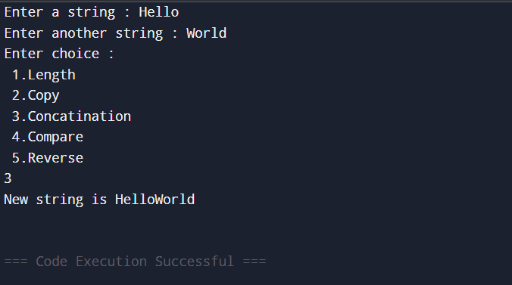

SAMPLE INPUT:
Enter first string: Hello
Enter second string: World
Choice: 3

SAMPLE OUTPUT:
Concatenated string: HelloWorld

CONCLUSION: Thus, the C program successfully demonstrates different string operations using built-in functions through a menu driven approach, making the program interactive and easy to use.

FAQs:
- What are built-in string functions in C and why are they used?
- What is the purpose of the string.h header file in C programs?
- How does a menu driven program improve user interaction in programming?

